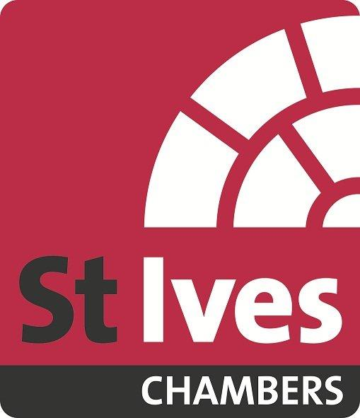

PUPILLAGE APPLICATION FORM

Confidential Closing Date: 23rd February 2018 Reference No. 2018/

PERSONAL DETAILS: PART A

PLEASE USE BLOCK LETTERS

Full name

Address

Tel:
Mobile:
Email:

EDUCATION AND QUALIFICATIONS: PART B

SECONDARY

From To Name of School/College & Examination Results (list subjects, level and grades)

EDUCATION AND QUALIFICATIONS contd.

ACADEMIC & PROFESSIONAL

From To University etc., Subject and Examination Results

Inn of Court:

Date of Call to the Bar:

Other training courses attended:

From To Institution & Examination Results

Other qualifications, membership of professional bodies:

EMPLOYMENT/ CAREER HISTORY: PART C
(Please put most recent first indicating whether a full-time or vacation job)

From To Employer Position held and responsibilities

Please continue on a separate sheet if necessary

LEGAL EXPERIENCE: PART D
Please include details of any legal experience, mini-pupillages, relevant unpaid or voluntary work, mooting or other skills, relevant to being a pupil and practising at the Bar.

INTERESTS/ACHIEVEMENTS/OTHER INFORMATION: PART E
Please include details of other achievements, interests and any other information you would like us to know about, relevant to being a pupil and practising at the Bar.

Please continue on a separate sheet if necessary.

What makes you want to be a barrister and why have you applied to St Ives Chambers?

Have you previously applied for pupillage at St Ives Chambers (if yes, when)?

REFERENCES: PART F

Please give the names and addresses of two people who can confirm your employment and/or academic record.

Name

Address

Name

Address

